Edit Profile In Dashboard

Overview :The Edit Profile section allows owners to update their account information, including name, email address, mobile number, password, and security settings. It also provides the option to enable Two-Factor Authentication (2FA) for enhanced account security. Any changes to the email or mobile number require OTP verification before they can be saved.

Path : Billing.petpooja.com >> Setting >> Edit Profile

outletwise_link : https://billing.petpooja.com/users/edit_profile

Steps to reach Edit Profile:
Step 1 : Billing.petpooja.com in Steps to reach Edit Profile : Open your browser and go to billing.petpooja.com.
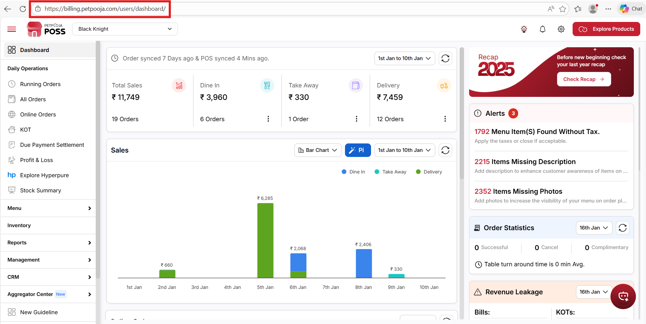
{Image Name: PetPooja Dashboard,
Description: The highlighted URL indicates that this is the billing.petpooja.com.Here is an image of step 1 Billing.petpooja.com in Steps to reach Edit Profile}
Step 2 : Setting in Steps to reach Edit Profile : Click on the Setting section from the dashboard.
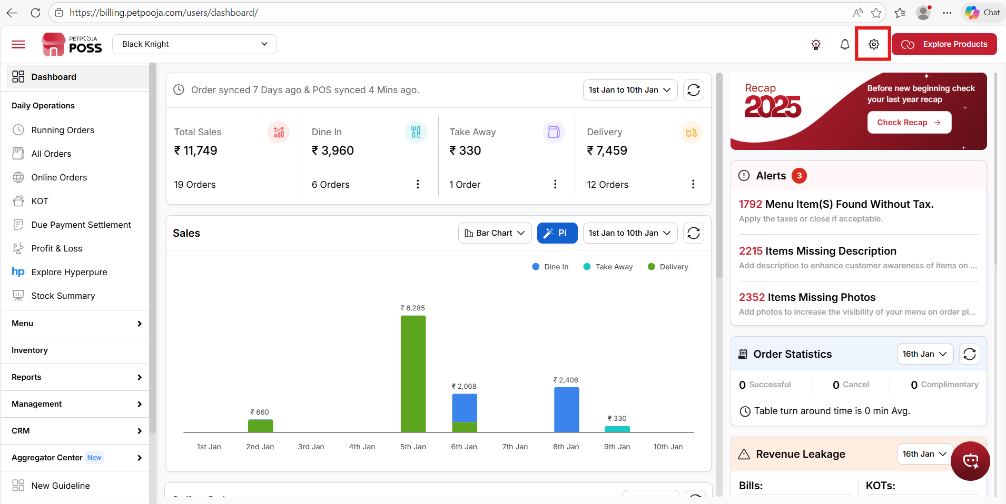
{ Image Name: Settings Highlight,
Description: The "Settings" is highlighted in the top right corner of the PetPooja dashboard. Here is an image of step 2 Setting in Steps to reach Edit Profile }

Step 3 : Edit Profile in Steps to reach Edit Profile : Click on Edit Profile to update your account or outlet details.
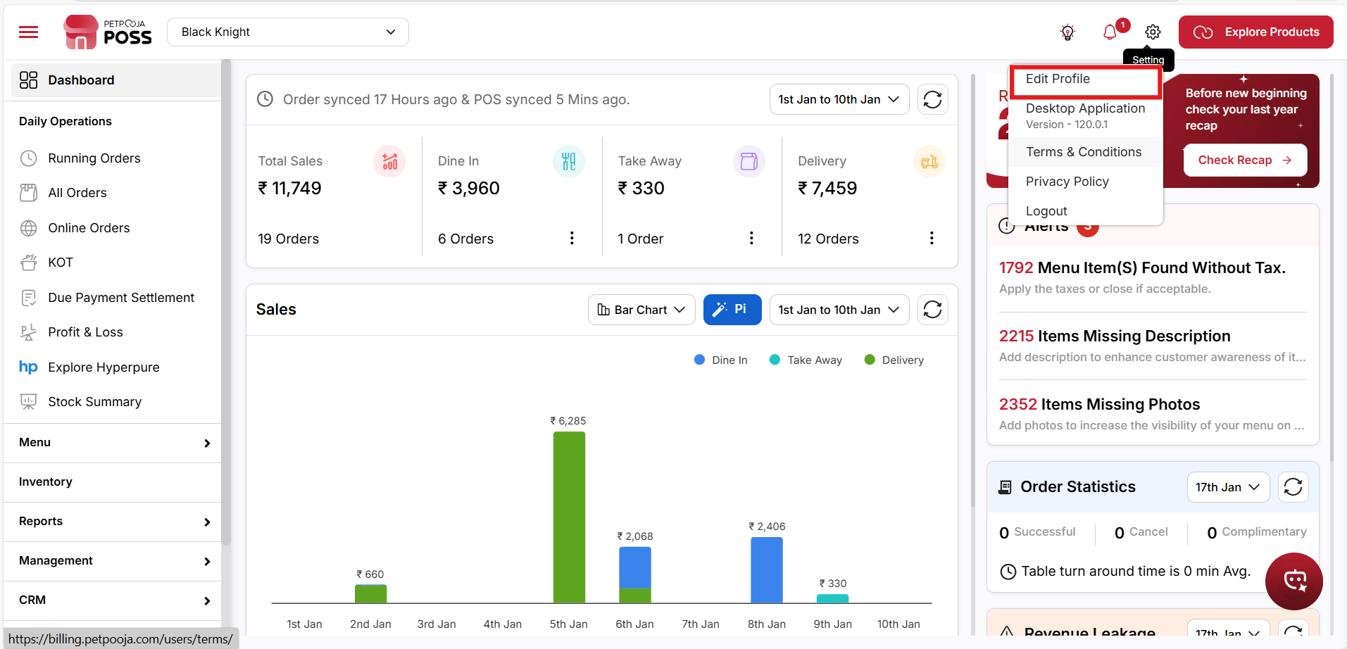

{ Image Name: Edit Profile Access,
Description: This image shows how to access the "Edit Profile" section from the Petpooja POS dashboard using the settings dropdown menu.Here is an image of step 3 Edit Profile in Steps to reach Edit Profile }

(Owner Details Edit) Edit Profile

(Edit Profile) User Information : The User Information section allows owners to edit personal details like name, email, and mobile number. It also provides options for verification and ensuring the entered details are correct.
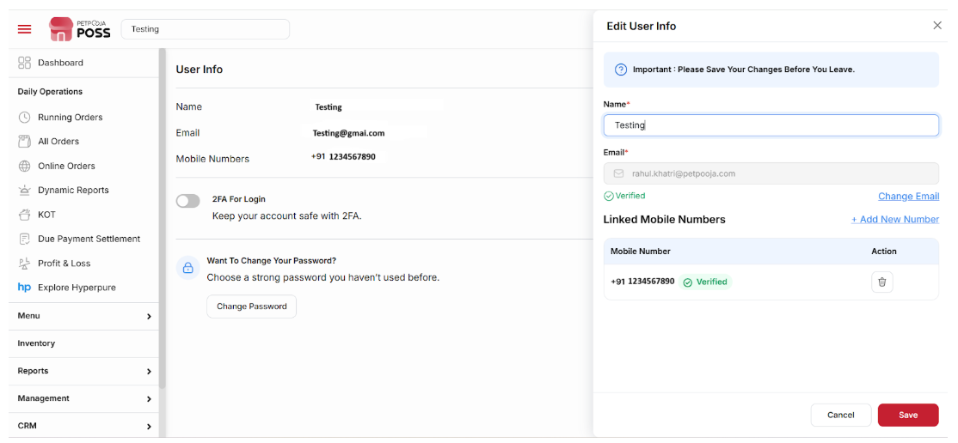
{ Image Name: PetPooja Settings - Edit User Information,
Description: The "User Information" section with in PetPooja's settings is displayed }

outletwise_link : https://billing.petpooja.com/users/edit_profile

- (Edit Profile) Name: Enter the owner's full name. This is a mandatory field.
- (Edit Profile) Email :Enter the owner's registered email address. This is a mandatory field and is used for login and communication.
To change the email address:
- Click the Edit button.
- An OTP will be sent to your current registered email address.
- Enter the OTP to verify your identity.
- After verification, you can enter and save the new email address.

- (Email) Verify Email:
After entering the new email address, a verification link or OTP will be sent to your email. Enter the OTP or click the link to confirm your email address. This ensures your email is successfully updated and linked to your account.
- (Edit Profile) Mobile:
Enter the owner's mobile number with the country code. This field is required.
To add or update a mobile number: Enter the new number and click "Verify Mobile Number". An OTP will be sent to the entered mobile number. After entering the OTP, the mobile number will be saved.
- (Edit Profile) Remove Mobile Number:
To remove the mobile number, click the cross (×) icon next to the mobile number field. The number will be removed.
- (Edit Profile) Verify Mobile Number:
After entering the new mobile number, enter the OTP received on your mobile to verify the number.
- (Edit Profile) Cancel:
Click Cancel if you want to discard the changes and exit without saving.
- (Edit Profile) Save:
After checking and verifying the updated details (name, email, and mobile number), click Save to store the changes.

(Owner Details Edit) Security : The Security section enables owners to securely update their password. This is a critical feature for maintaining account integrity.
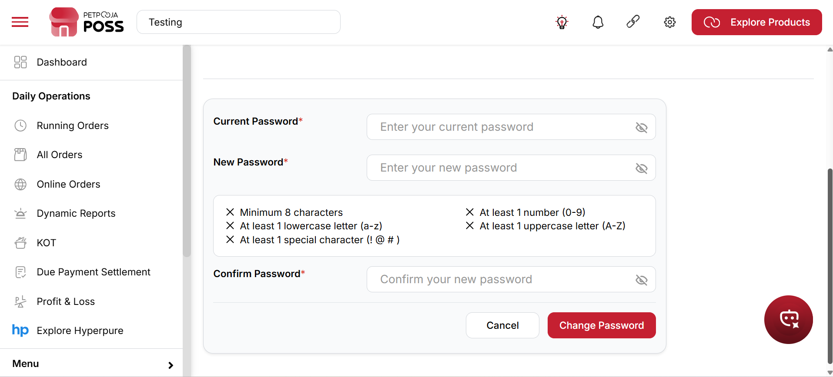
{ Image Name: PetPooja Settings - Security,
Description: The "Security" section within PetPooja's settings is displayed. It provides fields to update the Owner password }

outletwise_link : https://billing.petpooja.com/users/edit_profile
- (Security) Current Password: Enter the existing password to authenticate the password change request. This field is mandatory for authorization.
- (Security) New Password: Enter the new password you wish to set. Ensure it follows the password strength guidelines to enhance account security. This is a mandatory field.
- (Security) Confirm Password: Re-enter the new password to ensure it matches the previously entered password. This is a mandatory field to prevent errors.
(Security) Note: X Minimum 8 characters
X At least 1 lowercase letter (a-z)
X At least 1 special character (! @#)
X At least 1 number (0-9)
X At least 1 uppercase letter (A-Z)

(Owner Details Edit)Two Factor Authentication : Two-Factor Authentication (2FA) provides an extra layer of security for your account, making it harder for unauthorized individuals to gain access. It acts as a protective barrier beyond just your password.
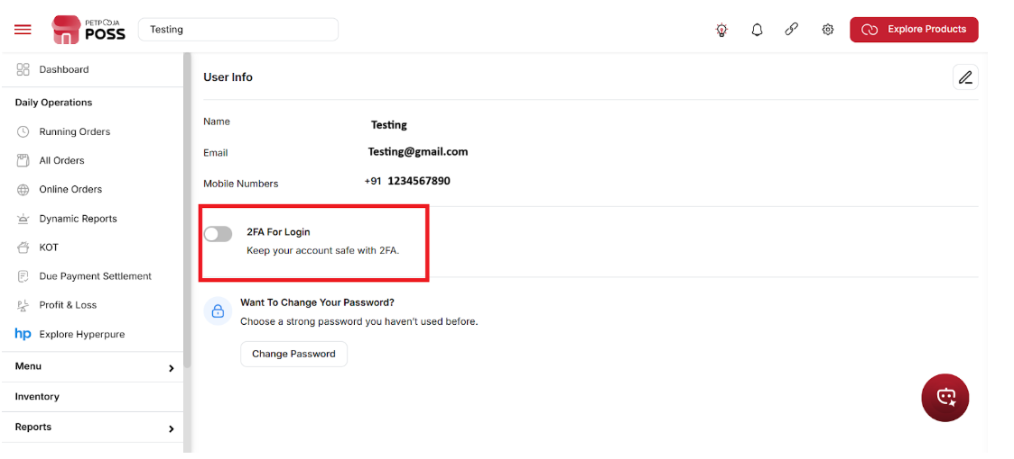
{ Image Name: Two Factor Authentication,
Description: The "Two Factor Authentication" section in PetPooja's settings is shown }

- (Two Factor Authentication)
By enabling this option, the system will ask for an additional verification (like an OTP) after you enter your password. This extra security step helps protect your account and ensures that only you or authorized users can access it.
- (Two Factor Authentication) How it works:
- Password Protection:
A password alone may not be enough to keep your account safe. If someone gets your password, they may access your account. With 2FA enabled, they will also need a second verification step to log in.
- Extra Verification Step:
After entering your password, you need to verify your identity using another method. Usually, an OTP is sent to your registered email address or mobile number. You can log in only after entering the correct OTP.
- Prevents Unauthorized Access:
Even if someone knows your password, they cannot access your account without the OTP verification. This helps protect your account from unauthorized access and keeps your data secure.

